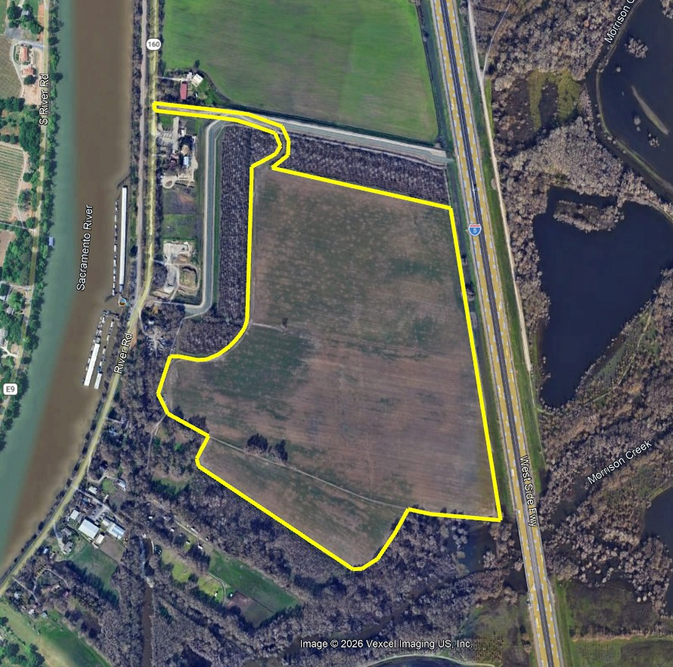
The premises are outlined and contain approximately 108 acres

Portions of APNs: 119-0020-048 and 049

